TRAINING CATALOG CORRIDIS
1

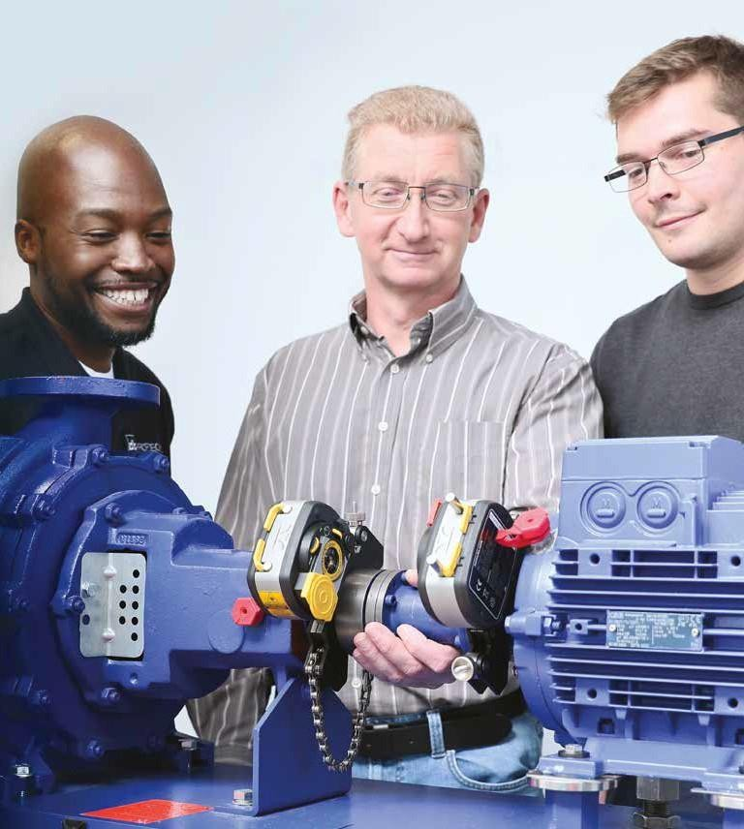
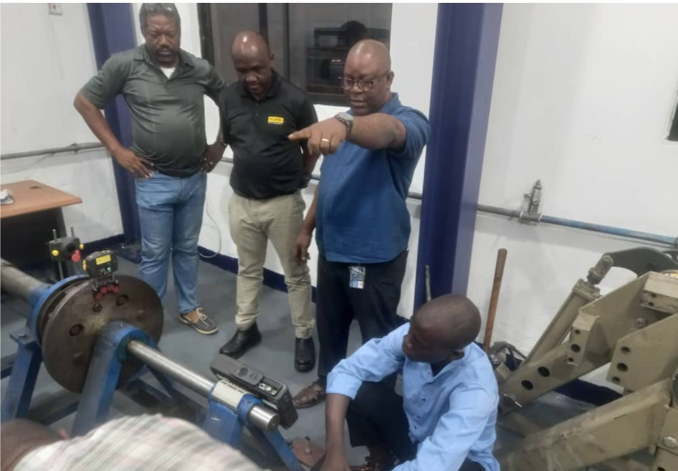

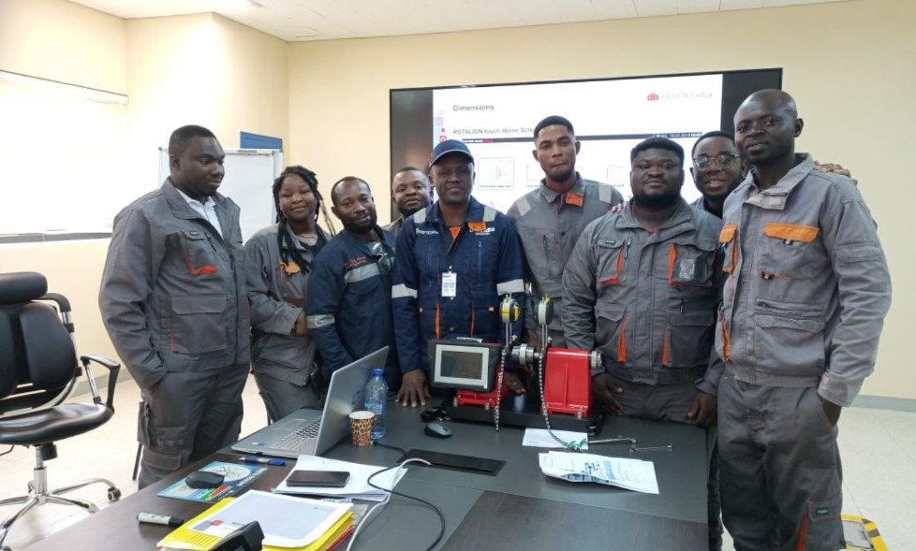
Methodology
Our training is based on the principle of andragogy: learning by doing.
The method will therefore be both practical and participatory, utilizing the tools listed below:
Before the training: pre-training assessment
In order to develop a concrete proposal tailored to your company and the future participants, we will carry out the following steps:
Gain an understanding of the company’s organization and culture, trainee profiles, expectations, objectives, and desired outcomes,
Schedule individual interviews with a sample of participants, line managers, and the trainer,
Develop the final training program with top management and the training department,
A pre-test and a survey of each participant’s expectations will be conducted to better understand their needs and ensure they are met.
During the training sessions
Dynamic and participatory facilitation of the sessions
•Encouraging the generation of ideas and the exchange of experiences among participants
•Brainstorming
•Simulation of the tools covered in the classroom, allowing for
to divide participants into working groups for simulations. The results are then presented in a plenary session for discussion
•Educational awareness-raising games in the classroom
•Reflection and analysis work in groups
•Daily debriefing, in which rapporteurs are designated for each day; these rapporteurs are responsible for giving a brief presentation the following day, before the program begins, summarizing all the work from the previous day.
•Screening of training films
Practical application of theoretical learning
At the end of each training session, each participant will be invited to make commitments to improvement; each commitment will be filmed and submitted to the Human Resources department for better post-training follow-up
Continuous training evaluation
A pre-training assessment will measure each participant’s initial level through a role-playing exercise that the consultants have mastered.
The trainer is required to write a training report that summarizes all the content covered during the learning process and analyzes the process itself.
This document will be submitted no later than 7 business days after the training is completed.
After our training sessions: Optional post-training follow-up (billed separately)
Scheduled visits to participants’ sites to verify the implementation of individual improvement plans.

Trainees, 95% satisfaction rate

Dear Customer CORRIDIS Reliability

Maintaining machines in operational condition has become essential today. This is why many companies have equipped themselves with vibration measurement systems, bearing diagnostics
and laser alignment systems. These analysis and correction tools will only be effective if users are confident in their operation and possess sufficient knowledge to interpret the results.

CORRIDIS offers a comprehensive range of training courses detailed in this document in the form of “Product-oriented” workshops. These courses are designed to facilitate the rapid implementation of vibration analysis and
laser alignment into your maintenance policy using our measurement devices. Our training courses include clear and effective digital and printed materials. These training tools enable users to quickly become proficient in using condition-based maintenance tools.

The training courses are accessible to anyone with a disability, subject to the adaptation of the company’s facilities, materials, and work tools.

CORRIDIS vibration training courses are led by vibration analysis engineers certified to ISO 18436-2
All our training courses can be conducted on-site within approximately two months. A daily rate is applied, which includes a flat fee for travel expenses. The training courses, available year-round, are conducted with a minimum of one participant and a maximum of six.

We ensure that the necessary equipment for practical exercises is available. If not, rental options are available. Our training sessions are led alternately by two instructors, all of whom are carefully selected by us.

We provide over 800 hours of in-house training annually, and we have trained more than 25,000 participants over the past 20 years with a 95% satisfaction rate.

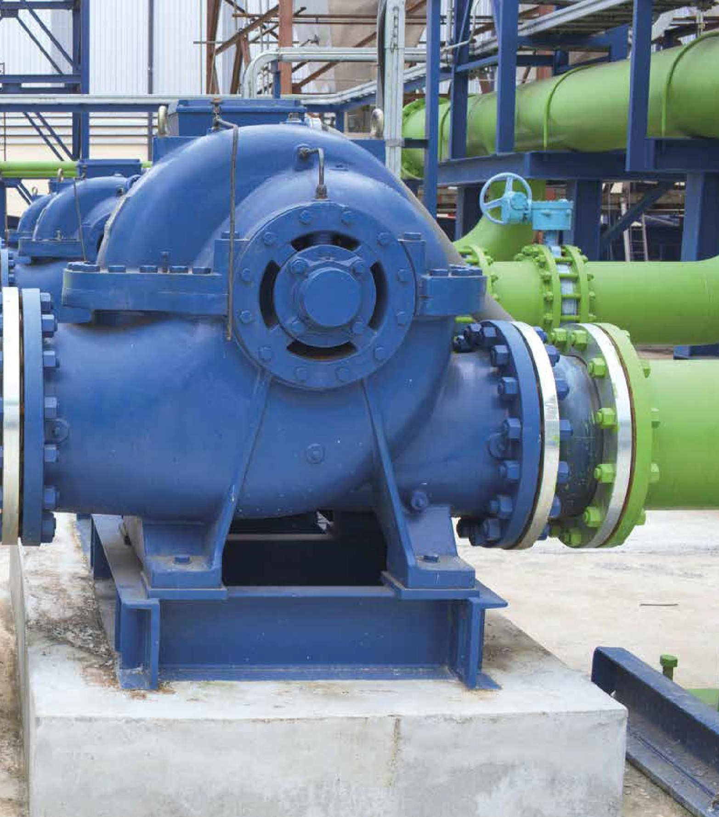

OBJECTIVES:

Level I: Equipment and Software
VIBXPERT® or VIBSCANNER® and OMNITREND®
Comprehensive vibration measurement Reference: F_CM_G
.
Level I:
Equipment and Software

Profile: Maintenance personnel,
technicians, engineers

Prerequisites: Technical training, knowledge of mechanics.

Teaching Methods: Presentation may include videos, 3D animations, and PC simulations
Sharing experiences
with trainees

Assessment methods: Multiple-choice questions
Certificate of completion Progress report

Duration:
3 days
Day 1 / Equipment
- Perform vibration measurements on rotating machinery in accordance with ISO 10816
- Identify the machine group according to ISO 10816
- Identify permissible limits
- Configure the measurement device according to ISO 10816
- Create a measurement report in Word and Excel (VibXpert)
- Complete and edit the inspection report
Day 2 / Equipment
- Perform vibration inspections on the bearings of rotating machinery
- Set permissible thresholds
- Program the measurement device for bearing inspection
- Create a measurement report in Excel and Word
- Complete and edit the inspection report
Day 3 / Software
- Manage communication between the software and the device
- Select strategic machines
- Create a machine database
- Create data points associated with appropriate global measurements
- Generate machine graphs displayed on the device
- Set alert thresholds
- Conduct rounds
- Write comments and instructions
- Generate standard reports

PRICE: Please contact us
At the client’s site (maximum 6 people)

OBJECTIVES:

Level II: Equipment and Software
VIBXPERT® and OMNITREND® training course: vibration measurement with FFT, diagnostics of rotating machinery.
Reference: F_CM_D
Level II:
Equipment and Software

Profile: Maintenance personnel,
technicians, engineers

Prerequisites:
F_CM_G

Teaching Methods: Presentation may include videos, 3D animations, and PC simulations
Sharing experiences
with trainees

Assessment methods: Multiple-choice questions
Certificate of completion Progress report

Duration:
2 days
Day 1 / Equipment
- Understanding complex vibration signals
- Reading a spectrum
- Identifying machine-related frequencies
- Program the measuring device to diagnose an imbalance or misalignment issue
- Identify these defects using the device
- Prepare a diagnostic report
Day 2 / Device - Software

- Program the measuring device to diagnose a bearing problem
- Program the functions related to Level 2 diagnostics
- Create measurement tasks
- Programming alert thresholds and alarm bands
- Program the characteristic frequencies of the faults studied in Level 2
- Manipulating diagnostic cursors
- Performing rounds
- Analyzing measurements

PRICE: Please contact us
At the customer’s site (maximum 6 people)

Unbalance in a rotating machine creates significant dynamic forces at the bearings. Proper vibration monitoring allows

Level II: Balancing of Rotating Machinery
Hands-on training focused on detecting and correcting imbalance in rotating shafts.
Reference: F_CM_P
Level II: Balancing of Rotating Machinery

Profile: Maintenance personnel,
technicians, engineers

Prerequisites: Technical training, knowledge of mechanics.

Teaching methods: Presentation may include videos, 3D animations, and PC simulations
Sharing of experiences
with trainees

Assessment methods: Multiple-choice questions
Certificate of completion Progress report

Duration:
3 days
to verify that the issue is indeed an imbalance, and then to correct it by performing a 1- or 2-plane balancing procedure.
The practical portion of the training can be conducted using the VIBSCANNER® or the VIBXPERT®.

OBJECTIVES:

- Basic concepts of balancing (terminology and physical quantities)
- Regulatory framework: ISO 1940 standard
- Differentiation through the measurement of static, torque, and dynamic unbalance
- Assessing the need for balancing
- Detection of a machine’s resonance zones (impact test and tracking filter)
- Presentation and setup of the measurement system
- Practical performance of 1-plane and 2-plane balancing

PRICE: Please contact us
At the customer’s site (maximum 6 people)

Customized training
Customized training course: vibration expertise and consulting Reference: F_CM_EXP

Targeted training designed to meet the client’s specific needs. Customized program to be defined by the client and FLUKE France.
Customized Training Course:

Profile: Maintenance staff,
technicians, engineers

Prerequisites: Technical training, knowledge of mechanics.

Teaching methods: Presentation may include videos, 3D animations, and PC simulations
Sharing experiences
with trainees

Assessment methods: Multiple-choice questions
Certificate of completion Progress report

Duration:
To be determined

OBJECTIVE:

Develop your skills in the vibration diagnosis of your machines and the analysis of your databases.

EXAMPLE OF CONTENT:

- Gear defects
- Belt defects
- Bearing defects
- Report generation with Omnitrend Web
- Orbital measurements
- Database updates
- Bearing installation and removal

RATE: Please contact us
At the customer’s site (maximum 6 people)

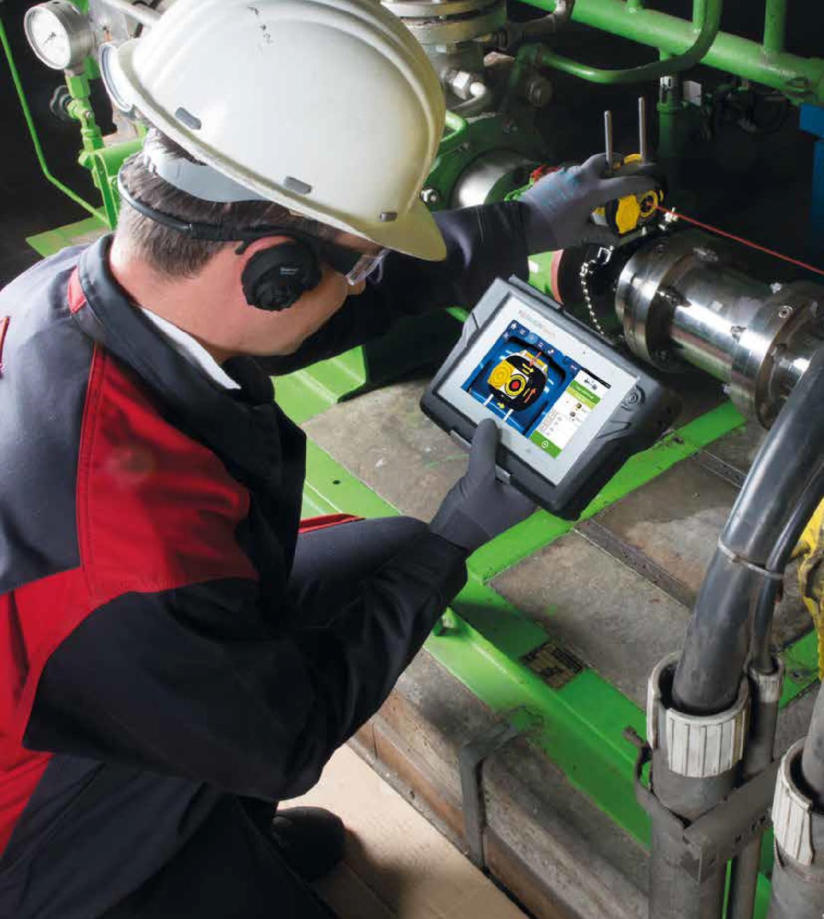
Laser alignment

OBJECTIVES:

Training in the alignment of two machines with direct coupling (simple kinematics)
Reference: F_ALI_S

Profile: Maintenance personnel,
technicians, engineers

Prerequisites: Technical training, knowledge of mechanics.

Teaching methods: Presentation may include videos, 3D animations, and PC simulations
Sharing experiences
with trainees

Assessment methods: Multiple-choice questions
Certificate of completion Progress report

Duration:
3 days
Understand what machine alignment is, its objectives and benefits, how the laser aligner works, and how to align two machines in various scenarios using the laser.

CONTENT:

- Introduction to and understanding of laser technology: the device, computer, and sensors
- Entering machine dimensions
- Using ‘static’ and ‘active clock’ modes
- Measuring at multiple points on machines with plain bearings and decoupled machines
- Understanding the results
- Correcting alignment
- Practical exercise: Aligning two machines within their tolerances
- Changing the reference frame
- Align to target values // thermal expansion
- Practical exercise: Aligning to target values
- Analyze a wobbly base
- Save and print a report on a PC

PRICE: Please contact us
At the client’s site (maximum 6 people)

OBJECTIVES:

ROTALIGN® PRO | ROTALIGN® Ultra iS | ROTALIGN® Touch
Training in the alignment of two or more machines, with direct coupling, universal joint, or extension. Measurement quality analysis (standard deviation) Reference: F_ALI_R

Profile: Maintenance personnel,
technicians, engineers

Prerequisites: Technical training, knowledge of mechanics.

Teaching methods: Presentation may include videos, 3D animations, and PC simulations
Sharing of experiences
with trainees

Assessment methods: Multiple-choice questions
Certificate of completion Progress report

Duration:
3 days

Understand what machine alignment is, its objectives and benefits, how the laser aligner works, and how to align two or more machines in various scenarios using the laser.

CONTENT:
- Introduction to and understanding of laser technology: the device, computer, and sensors
- Machine dimensions
- Measurement modes to use for different scenarios: plain or rolling bearings, coupled or uncoupled shafts, rotating or stationary shafts.
- Understanding the results and using the measurement table
- Correcting alignment within tolerances
- Practical exercises: aligning two or three machines within their tolerances, with or without target values.
- Changing the reference frame
- Analyzing wobble
- Create a model
- Save and print a report on a PC
PRICE: starting at €2,481.00 (excl. tax)
At the client’s site (maximum 6 people)

OBJECTIVE:

Inter-company "PROFESSIONAL" TRAINING - EXPERT Level
EXPERT-level training in alignment techniques.
Reference: AMT01

Profile: Maintenance personnel,
technicians, engineers

Prerequisites: Technical training, knowledge of mechanics.

Teaching methods: Presentation may include videos, 3D animations, and PC simulations
Sharing experiences
with trainees

Assessment methods: Multiple-choice questions
Certificate of completion Progress report

Duration:
2 days

By the end of the training, participants will be able to: Anticipate thermal and dynamic phenomena; Perform complex alignment (3 or more machines); Master graphical and mathematical methods.

CONTENT:
- Machine Line Alignment
- What is machine train alignment?
- Graphical method.
- Managing movement limits.
- Thermal expansion and dynamic movements
- Introduction.
- Thermal and mechanical effects.
- Handling dynamic changes.
- Target values.
- Mathematics of alignment
- Isometric triangles.
- Triangles and alignment.
- Triangles formed by two concentric circles.
- Working with negative values.
"Expert" exam

PRICE: starting at €3,879.00 (excl. tax)
At the client’s site (maximum 6 people)

